PROJECT DOCUMENTATION
TEAM ID : SWTID-2026-7900
IMPLEMENT CLIENT SCRIPT & UI POLICY (INCIDENT)

1. Introduction

Project Title
IMPLEMENT CLIENT SCRIPT & UI POLICY (INCIDENT)

Team Members
- DIVYA DARSHINI L
- SARULATHA S
- NAMITHA B
- BHAVATHARANI P
- ROOPIKA S

2. Project Overview

Purpose
The project demonstrates the use of ServiceNow UI Policies and Client Scripts to improve data consistency and accuracy in Incident records.
Manual data entry can result in incomplete or inconsistent Incident information. The project introduces conditional field behavior, automated field updates, save-time validation, and restrictions on list editing to ensure that Incident records follow defined business rules.

Features
- Makes Assignment Group mandatory when Impact is High.
- Makes Urgency read-only when Impact is High.
- Automatically sets Urgency to High when Impact changes to High.
- Prevents saving a High Impact Incident when Assigned To is empty.
- Prevents State from being modified through list editing.
- Reverses conditional field behavior when the Impact condition is no longer satisfied.
- Allows State changes through the Incident form.
- Provides testing activities to verify all implemented controls.

3. Architecture

Platform Architecture
The project is implemented within the ServiceNow platform, using the Incident table, UI Policies, UI Policy Actions, and Client Scripts.

User Interface
The Incident form and Incident list provide the user interface through which users create, modify, and update Incident records.
The UI dynamically responds to the value of the Impact field.

Application Logic
The application logic is implemented using:
- UI Policy – controls conditional field behavior.
- UI Policy Action – controls field properties such as mandatory and read-only.
- onChange Client Script – automatically updates Urgency when Impact changes.
- onSubmit Client Script – validates Incident data before submission.
- onCellEdit Client Script – controls State changes made through list editing.

Data
The project operates on the Incident table in ServiceNow. The relevant fields include:
- Impact
- Assignment Group
- Assigned To
- Urgency
- State
The project does not specify a separate external database or database integration.

4. Setup Instructions

Prerequisites
The following are required:
- Access to a ServiceNow instance.
- Appropriate permissions to configure Incident records.
- Access to System UI → UI Policies.
- Access to System UI → Client Scripts.
- Access to the Incident application/module.
- A browser capable of accessing the ServiceNow instance.

Implementation Setup
- Log in to the ServiceNow instance.
- Navigate to System UI → UI Policies.
- Create the UI Policy named High Impact Control.
- Set the table to Incident.
- Configure the condition:
  - Field: Impact
  - Operator: is
  - Value: 1 – High
- Configure the UI Policy Action for Assignment Group.
- Create the Urgency UI Policy Action and make Urgency read-only.
- Navigate to System UI → Client Scripts.
- Create the required:
  - onChange Client Script
  - onSubmit Client Script
  - onCellEdit Client Script
- Test the configured behavior using Incident records.

5. Folder / Configuration Structure
Since this is a ServiceNow configuration project rather than a MERN application, the project does not use a conventional client/server folder structure.
The logical project structure is:
ServiceNow Incident Project
│
├── Incident Table
│ ├── Impact
│ ├── Assignment Group
│ ├── Assigned To
│ ├── Urgency
│ └── State
│
├── UI Policies
│ └── High Impact Control
│
├── UI Policy Actions
│ ├── Assignment Group
│ └── Urgency
│
└── Client Scripts
├── Auto set urgency for high impact
├── Prevent save if Assigned To missing
└── Prevent state change via list edit

6. Running the Application
The project does not require separate frontend and backend servers.

Accessing the Project
- Log in to the configured ServiceNow instance.
- Open the Incident module.
- Create a new Incident or open an existing Incident.
- Change Impact to High.
- Observe the configured UI Policy and Client Script behavior.
- Perform the documented testing activities.

Verification
When Impact is High:
- Assignment Group should become mandatory.
- Urgency should become read-only.
- Urgency should automatically be set to High.
- Saving without Assigned To should be prevented.
When State is edited directly from the Incident list:
- An alert should appear.
- The State change should be blocked.

7. API / Script Documentation
This project does not expose REST APIs as part of the documented implementation. Instead, it uses ServiceNow Client Scripts.

7.1 onChange Client Script
Name: Auto set urgency for high impact
Table: Incident
Type: onChange
Field: Impact
Purpose: Automatically sets Urgency to High when Impact is High.
function onChange(control, oldValue, newValue, isLoading) {
if (isLoading || newValue == '') {
return;
}

if (newValue == '1') {
g_form.setValue('urgency', '1');
g_form.addInfoMessage(
'Urgency set to High for High impact incident.'
);
}
}

7.2 onSubmit Client Script
Name: Prevent save if Assigned To missing
Table: Incident
Type: onSubmit
Purpose: Prevents submission when Impact is High and Assigned To is empty.
function onSubmit() {
if (g_form.getValue('impact') == '1' &&
g_form.getValue('assigned_to') == '') {
g_form.showErrorBox(
'assigned_to',
'Assigned To is mandatory for High impact incidents.'
);
return false;
}

return true;
}

7.3 onCellEdit Client Script
Name: Prevent state change via list edit
Table: Incident
Type: onCellEdit
Field: State
Purpose: Prevents State from being changed through list editing.
function onCellEdit(sysIDs, table, oldValues, newValue, callback) {
alert(
'State cannot be updated using list editing. Please open the Incident.'
);
callback(false);
}

8. Authentication
Authentication is handled by the ServiceNow platform.
Users must log in to the authorized ServiceNow instance before accessing the Incident application.
The project itself does not implement a separate authentication mechanism such as:
- JWT
- OAuth implementation
- Custom sessions
- Password-based authentication system
Authorization and access to ServiceNow records are managed through the platform's existing access-control mechanisms. The provided project documentation does not specify additional custom authentication or authorization controls.

9. User Interface
The project uses the standard ServiceNow Incident interface.
The major UI elements demonstrated in the project include:

Incident Form
Used for:
- Creating Incidents.
- Editing Incident information.
- Changing Impact.
- Assigning users/groups.
- Updating State.

Dynamic Field Behavior
When Impact is set to High:
- Assignment Group becomes mandatory.
- Urgency becomes read-only.
- Urgency is automatically set to High.

Validation Message
If a High Impact Incident is submitted without Assigned To, the user receives an error and the Incident is not saved.

List Editing Restriction
When the user attempts to directly edit State from the Incident list, an alert is displayed and the change is blocked.
Screenshots to include:
- High Impact Incident form.
- Assignment Group shown as mandatory.
- Urgency shown as read-only.
- Automatically updated Urgency.
- Assigned To validation error.
- State list-edit restriction alert.
- Successful form-based State update.

10. Testing
Testing is performed using the Incident form and Incident list.

Test Case 1 – Mandatory Enforcement
Steps:
- Create a new Incident.
- Set Impact to High.
- Leave Assigned To empty.
- Submit.
Expected Result:
The Incident should not be saved and the validation message should indicate that Assigned To is mandatory for High Impact Incidents.

Test Case 2 – Successful Save
Steps:
- Set Impact to High.
- Fill Assigned To.
- Submit.
Expected Result:
The Incident should save successfully.

Test Case 3 – Reverse Condition
Steps:
- Open an Incident with Impact = High.
- Change Impact to Medium.
- Observe the fields.
Expected Result:
- Assigned To should no longer be mandatory.
- Urgency should become editable.
- Incident should save successfully.

Test Case 4 – List Edit Blocking
Steps:
- Open Incident → All.
- Double-click the State field.
- Attempt to change State.
Expected Result:
An alert should appear and the State should remain unchanged.

Test Case 5 – Form-Based Update
Steps:
- Open the Incident.
- Change State from the form.
- Select Update.
Expected Result:
The State change should be saved successfully.

11. Screenshots / Demo
The project demonstration should include screenshots showing the implementation and test results.
Task 1: Create UI Policy on Incident
Activity 1: Create UI Policy
1. Log in to the ServiceNow instance with administrative or configuration access.
2. Navigate to:
System UI → UI Policies
3. Click New to create a new UI Policy record.
4. Fill in the following details:
○ Name: High Impact Control
This name clearly represents the purpose of the policy, which is to apply
additional controls when an Incident has a high impact.
○ Table: Incident
Specifies that the UI Policy applies to Incident records.
○ Active: true
Enables the UI Policy so it is enforced on the Incident form.
5. Configure the Conditions section as follows:
○ Field: Impact
○ Operator: is
○ Value: 1 – High
6. This condition ensures the UI Policy is triggered only when the Incident impact is set to
High.
7. And Ui policy action Assignment group
8. Check mandatory
9. Set Reverse if false to true.
This ensures that when the condition is not met, any field changes applied by the policy
are automatically reverted.
10. Review the configuration to ensure accuracy.
11. Click Submit to save the UI Policy.
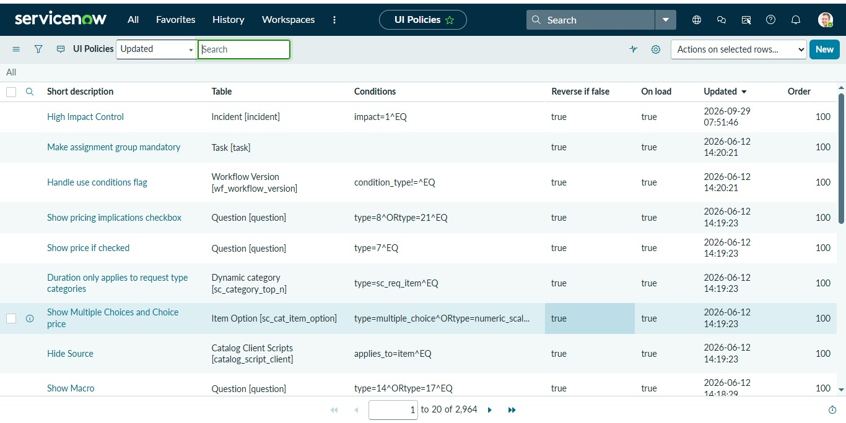

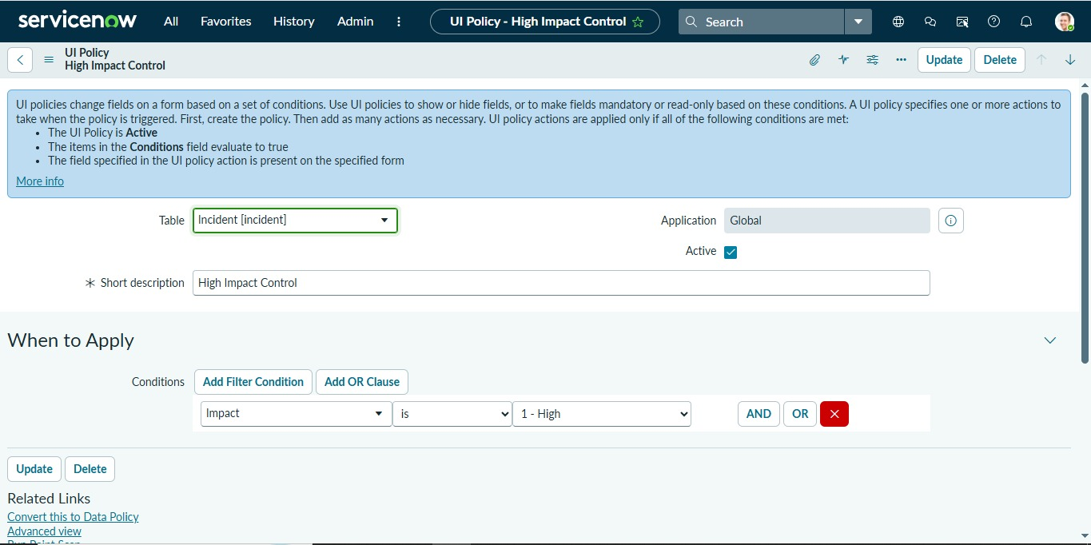
Task 2: Create UI Policy Action – Urgency
Activity 1: Configure the Urgency Field
1. Open the UI Policy Actions
Go to the High Impact Control UI Policy you created earlier. Scroll down to the UI
Policy Actions related list. This is where you define the specific behavior of fields when
the policy conditions are met.
2. Create a New Action
Click New to create a UI Policy Action. This lets you configure how individual fields
behave when the UI Policy is triggered.
3. Fill in the Action Details
○ Field name: Urgency
Select the Urgency field on the Incident form. This is the field you want to
control.
○ Read-only: true
Check this option to make the Urgency field read-only whenever the UI Policy
condition is met (Impact = High). Users will be able to see the field but cannot
change its value.
○ Visible: Leave this field as is (do not change).
By leaving it unchanged, the field will remain visible on the form, but its
behavior will be controlled by the Read-only setting.
4. Submit the Action
Click Submit to save the UI Policy Action. The action is now linked to the High Impact
Control UI Policy and will automatically apply to the Urgency field when an Incident has
High Impact.
5. Optional Verification
To test the action:
○ Open an Incident record.
○ Set the Impact field to High.
○ Check that the Urgency field becomes read-only.
○ Change Impact to a different value to confirm that the field reverts back if needed.

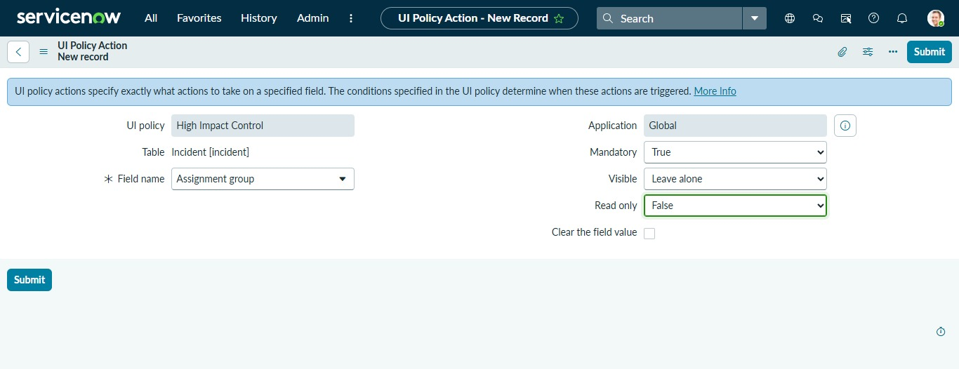

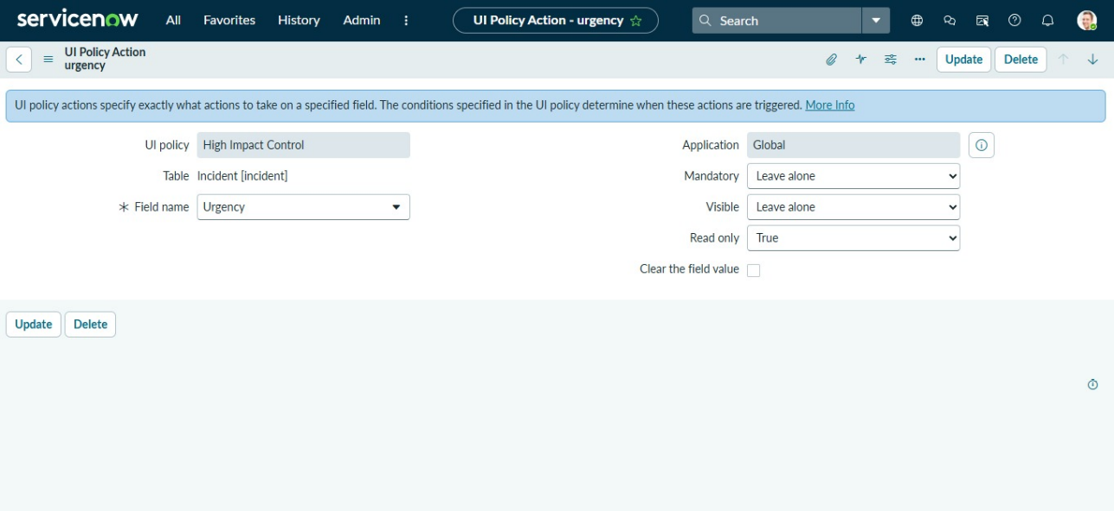

Task 3: Create onChange Client Script
Activity 1: Create Client Script
1. Navigate to Client Scripts:
Go to System UI → Client Scripts.
2. Click New to create a new Client Script.
3. Fill in the details:
○ Name: Auto set urgency for high impact – clearly shows the purpose.
○ Table: Incident – the script runs only on Incident records.
○ Type: onChange – executes when a field value changes.
○ Field name: Impact – triggers the script when Impact is updated.
○ Active: true – ensures the script runs immediately.
4. Paste the script in the script editor section.
5. Click Submit to save the Client Script.
6. Verify: Open an Incident record and change the Impact field to High. The Urgency field
should update automatically
Script:
function onChange(control, oldValue, newValue, isLoading) {
if (isLoading || newValue == '') {
return;
}
if (newValue == '1') {
g_form.setValue('urgency', '1');
g_form.addInfoMessage('Urgency set to High for High impact incident.');
}
}
- Click Submit.
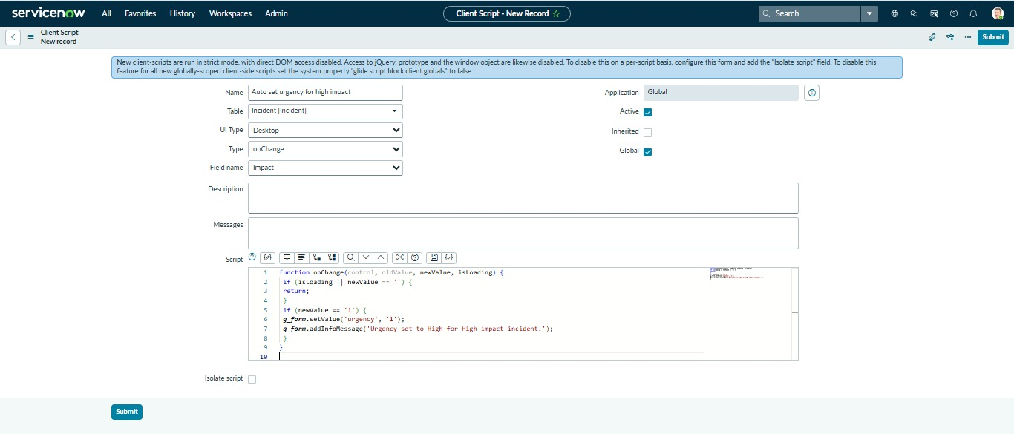
Task 4: Create onSubmit Client Script (Save Validation)
Activity 1: Create Client Script
1. Navigate to Client Scripts:
Go to System UI → Client Scripts in your ServiceNow instance.
2. Click New to create a new Client Script.
3. Fill in the details:
○ Name: Prevent save if Assigned To missing – clearly indicates that the script
prevents saving if the field is empty.
○ Table: Incident – applies the script only to Incident records.
○ Type: onSubmit – executes when the user tries to save the record.
○ Active: true – ensures the script is enforced immediately.
4. Paste the script into the script editor section. This script should check if the Assigned To
field is empty and prevent the record from saving if it is.
5. Click Submit to save the Client Script.
6. Verify: Try saving an Incident without filling the Assigned To field. The script should
prevent the save and display a warning.
7. Paste the script:
function onSubmit() {
if (g_form.getValue('impact') == '1' &&
g_form.getValue('assigned_to') == '') {
g_form.showErrorBox(
'assigned_to',
'Assigned To is mandatory for High impact incidents.'
);
return false;
}
return true;
}
- Click Submit.

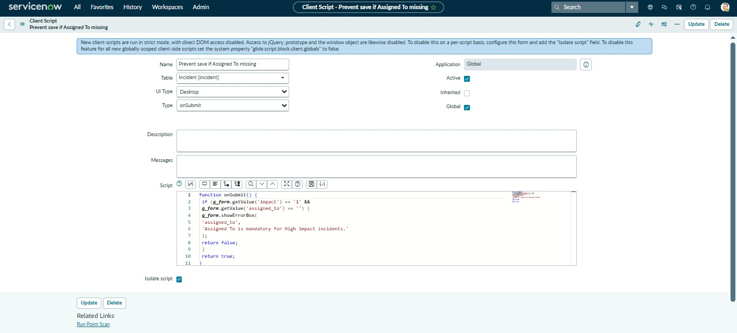

Task 5: Create onCellEdit Client Script
Activity 1: Create Client Script
1. Navigate to Client Scripts:
Go to System UI → Client Scripts in your ServiceNow instance.
2. Click New to create a new Client Script.
3. Fill in the details:
○ Name: Prevent state change via list edit – clearly indicates that the script prevents
users from changing the State field directly in a list.
○ Table: Incident – applies the script only to Incident records.
○ Type: onCellEdit – runs whenever a field is edited directly in a list view.
○ Field name: State – the script will monitor changes to the State field.
○ Active: true – ensures the script is enforced immediately.
4. Paste the script into the script editor section. The script should prevent unauthorized
changes to the State field when editing from the list view.
5. Click Submit to save the Client Script.
6. Verify: Open an Incident list and try to change the State field directly in the list. The
script should block the change as intended.
7. In the Script field, paste the following code:
function onCellEdit(sysIDs, table, oldValues, newValue, callback) {
alert('State cannot be updated using list editing. Please open the Incident.');
callback(false);
}
- Click Submit.
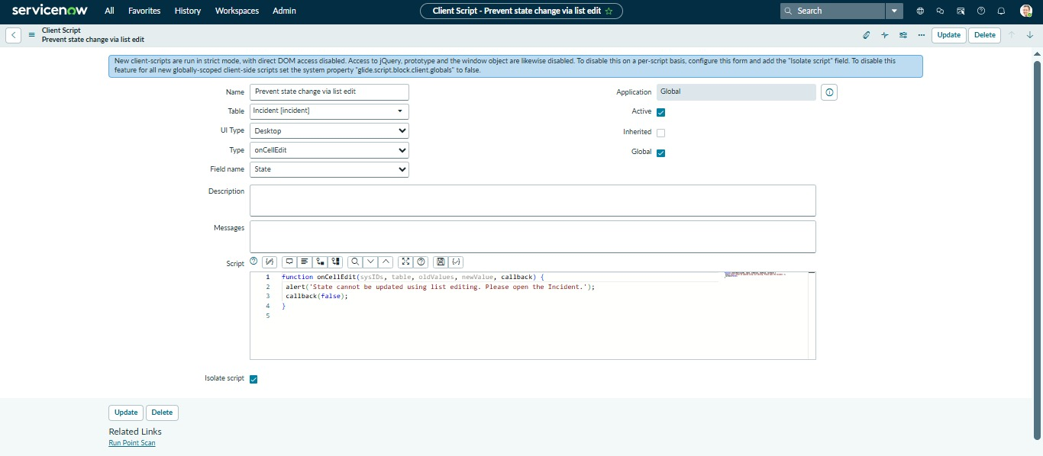

Task 6: Testing the Configuration
Activity 1: Test Mandatory Enforcement
1. Navigate to Incident:
Go to Incident → Create New to open a new Incident form.
2. Set the Impact Field:
Select High for the Impact field. This will trigger the UI Policy and Client Script
behaviors you configured earlier.
3. Leave Assigned To Empty:
Do not fill in the Assigned To field. This will test the onSubmit Client Script that
prevents saving if Assigned To is missing.
4. Click Submit:
Attempt to save the Incident record.
5. Verify the Result:
○ The Incident should not be saved because Assigned To is required when Impact
is High.
○ An error message should appear, indicating that the Assigned To field cannot be
empty.
○ Confirm that all UI Policy actions, such as read-only fields or automated urgency
updates, are working as expected.

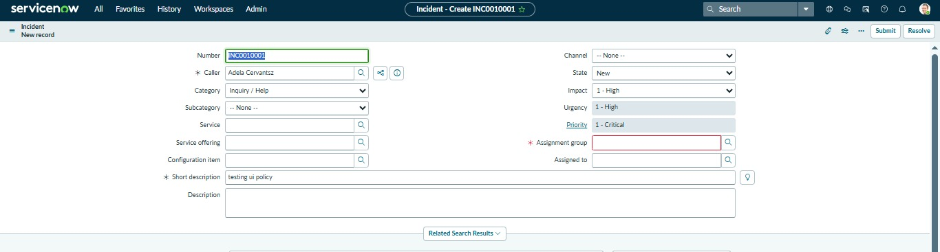

Activity 2: Test Successful Save
1. Fill the Assigned To Field:
Open the Incident form and select a user in the Assigned To field. This ensures the
onSubmit Client Script condition is satisfied.
2. Click Submit:
Attempt to save the Incident record.
3. Verify the Result:
○ The Incident should be saved successfully without any errors.
○ Confirm that all other configured behaviors, such as:
■ Urgency auto-setting (from the onChange Client Script)
■ Read-only fields (from the UI Policy Action)
■ State restrictions (from the onCellEdit Client Script)
are functioning as expected

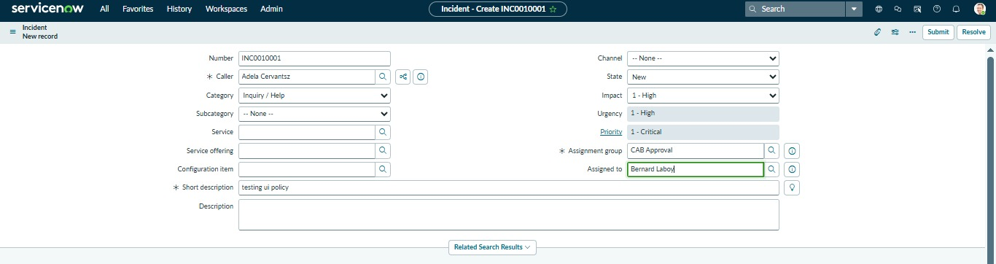

Activity 3: Reverse Condition Test
1. Open an Existing Incident:
Go to Incident → Open and select an Incident where Impact is currently set to High.
2. Change Impact:
Update the Impact field from High to Medium. This will test the Reverse if false
functionality of your UI Policy and the behavior of your Client Scripts.
3. Verify the Field Behavior:
○ Assigned To should no longer be mandatory.
○ Urgency should now be editable, meaning the read-only UI Policy action is
reversed.
4. Save the Record:
Click Submit to save the changes. The record should save successfully without errors,
confirming that the reverse condition works as intended.

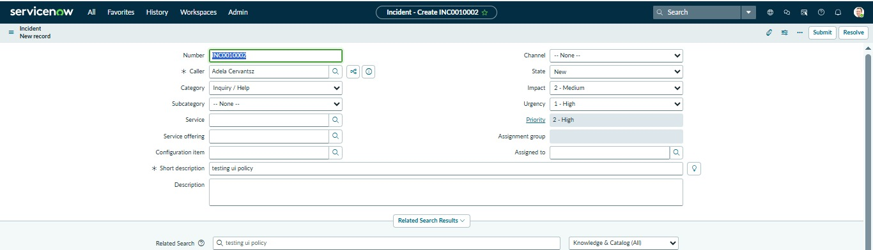

Activity 4: Test List Edit Blocking
1. Navigate to the Incident List:
Go to Incident → All to view all Incident records in a list view.
2. Attempt a List Edit:
○ Locate any Incident in the list.
○ Double-click the State field to try editing it directly from the list.
3. Verify the Behavior:
○ An alert message should appear, indicating that direct changes to the State field
are not allowed.
○ The State value should remain unchanged, confirming that the onCellEdit
Client Script is working correctly.

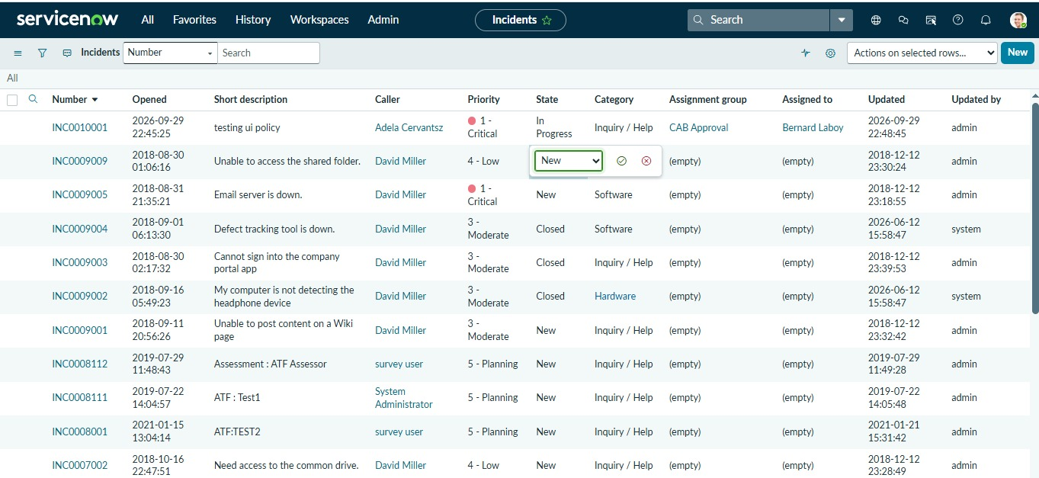

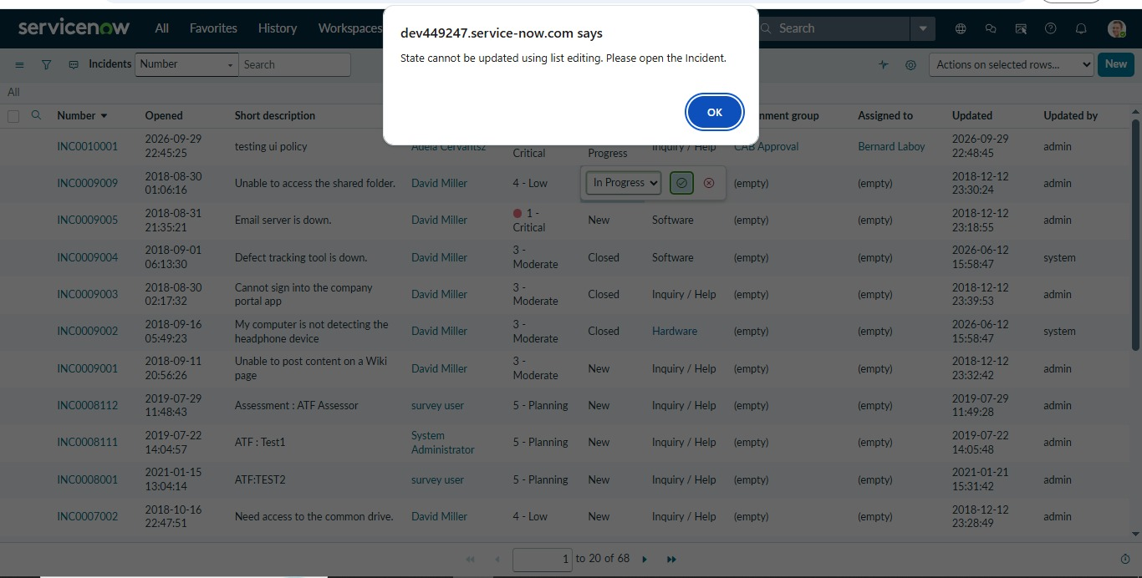

Activity 5: Test Form-Based Update
1. Open the Incident Record:
Navigate to the same Incident record you used in previous tests.
2. Change the State:
On the Incident form, update the State field to a new value. This tests that changes via
the form (not the list) are allowed.
3. Click Update:
Save the record by clicking Update.
4. Verify the Result:
○ The State change should be saved successfully.
○ Confirm that other fields, such as Assigned To and Urgency, still follow the
configured UI Policy and Client Script rules.

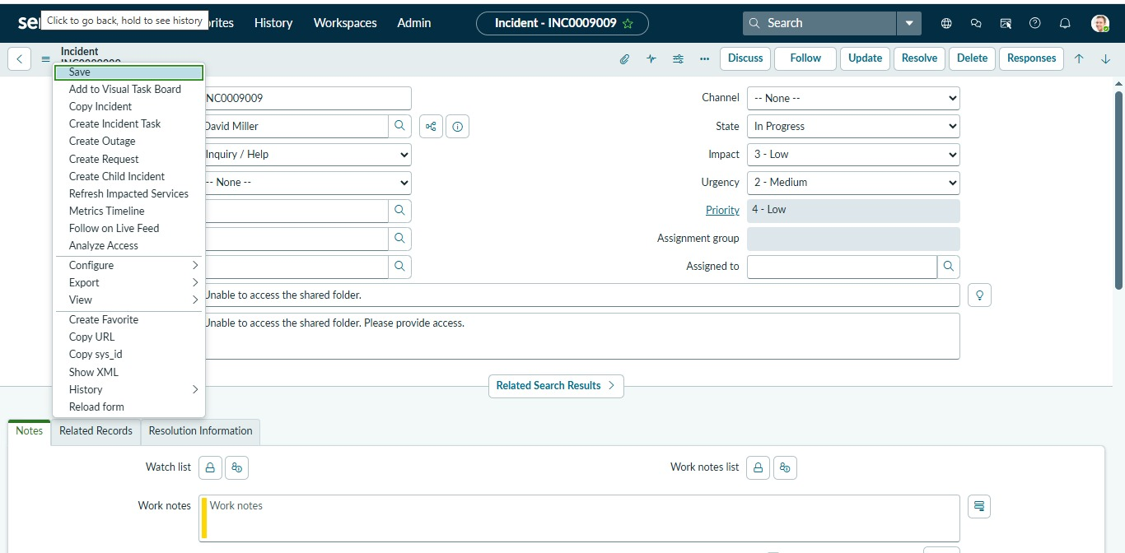
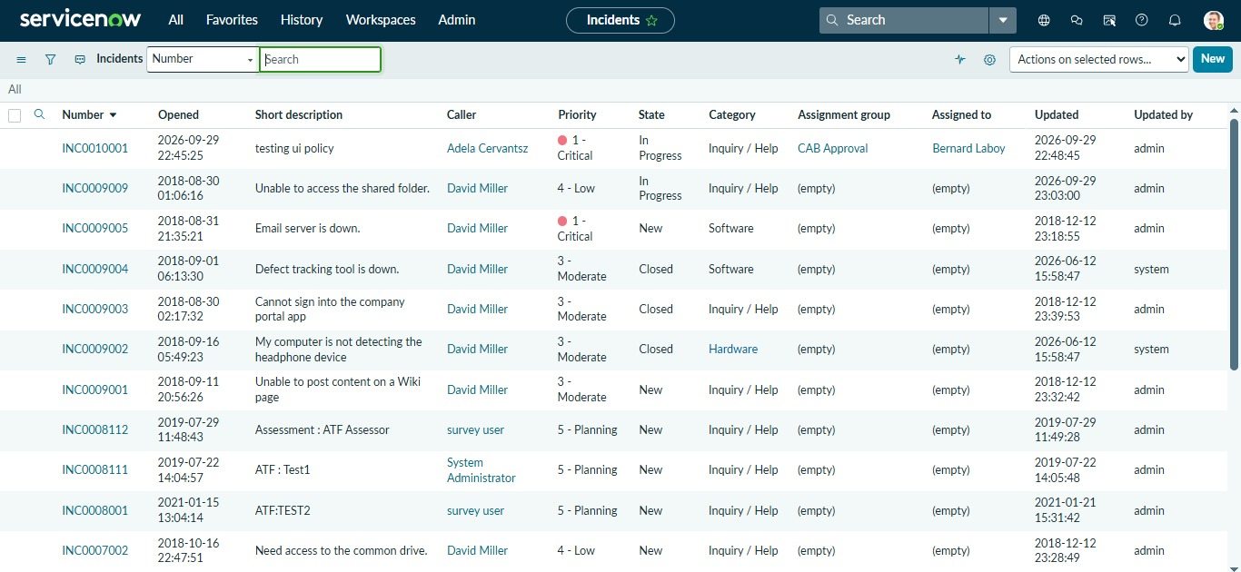

12. Known Issues
The following limitations should be noted based on the documented project:
- The project focuses on client-side controls within the Incident interface.
- The documented implementation does not describe a separate server-side validation mechanism.
- No external API integration is specified.
- No separate database integration is specified.
- No machine-learning component is specified.
- The project does not document a custom authentication system.
- The documented rules are specific to the Incident table and the defined Impact conditions.
- The project documentation uses Assignment Group for the UI Policy mandatory action while the save-validation rule checks Assigned To; these are treated as separate fields in the implementation.

13. Future Enhancements
Potential enhancements include:
- Additional Incident Validation
Add validation rules for other important Incident fields.
- Server-Side Validation
Complement client-side validation with server-side business rules where required.
- More Dynamic Field Controls
Introduce additional conditional behavior based on Impact, Urgency, Priority, Category, or State.
- Automated Assignment
Automatically determine Assignment Group or Assigned To based on Incident information.
- Enhanced Notifications
Provide automated notifications when important Incident conditions occur.
- Audit and Reporting
Track validation failures and field changes for analysis and reporting.
- Role-Based Controls
Introduce additional controls based on user roles and responsibilities.
- Automated Testing
Expand testing with automated ServiceNow test cases to verify the configured policies and scripts.
- Improved User Guidance
Provide clearer messages and contextual instructions when users enter incomplete or invalid information.
- Integration with Incident Workflows
Extend the project to integrate the client-side controls with broader Incident Management workflows.

